Name:_________________
Date:__________________
Homework #3
A toothpick pattern is shown below. Use the pattern for the following questions
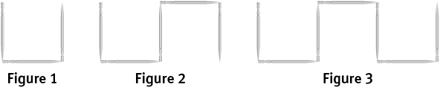
- Create a table to show the number of toothpicks in the first through the fifth figures, assuming the pattern continues.

- Write the number of toothpicks in each figure as a sequence. Does the sequence have a common difference? If so, identify it. If not, explain.

- How many toothpicks would be in the 15th figure? Justify your response using the sequence or the table.

- Use the variable n to write an expression that could be used to determine the number of toothpicks in any figure in the pattern.

